**CHAPTER 5 :UNDERSTANDING THE WIDGET TREE**

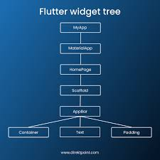In **Flutter**, the **widget tree** is a fundamental concept that governs how your app’s user interface (UI) is built and managed. Everything in Flutter is a **widget**, including the app layout, buttons, text, images, and even complex structures like lists and forms. The **widget tree** refers to the hierarchical structure of all these widgets, where widgets are nested inside other widgets.